**> Technical challenge**

**Please also produce a Design Document for this challenge**

1. Write a simple program in any language you want that outputs "I'm on %HOSTNAME%"

(HOSTNAME should be the actual host name on which the app is running) and deploy it to Github

vi test.sh

#!/bin/bash

hs=`hostname`

echo "I'm on "$hs""

sh test.sh

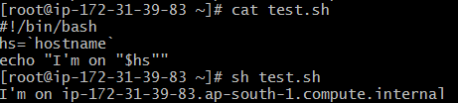

2. Write a Dockerfile which will run your app

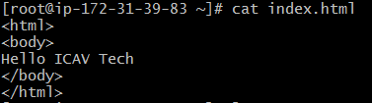

<html>

<body>

Hello ICAV Tech

</body>

</html>

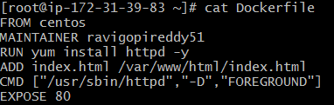

[root@ip-172-31-39-83 ~]# cat Dockerfile

FROM centos

MAINTAINER ravigopireddy51

RUN yum install httpd -y

ADD index.html /var/www/html/index.html

CMD ["/usr/sbin/httpd","-D","FOREGROUND"]

EXPOSE 80

[root@ip-172-31-39-83 ~]# docker build -t webwithdb .

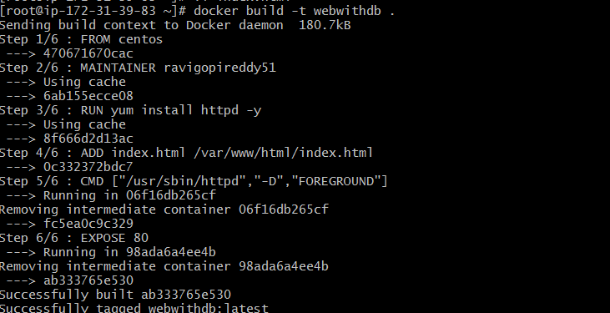

[root@ip-172-31-39-83 ~]# docker ps



[root@ip-172-31-39-83 ~]# docker run -d -p 82:80 webwithdb



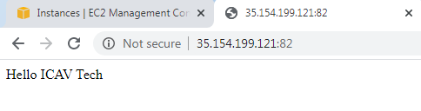

**Attach volume:**

[root@ip-172-31-39-83 apache]# docker run -d -p 84:80 -v /root/docker/apache:/var/www/html webwithdb

0ce40431358d2295e4ba9f5949febc3f89c5816a264ce6099c0cd144974a5546

[root@ip-172-31-39-83 apache]# cat index.html

<header>

<h1>ICAV Tech Test Challenge </h1>

</header>

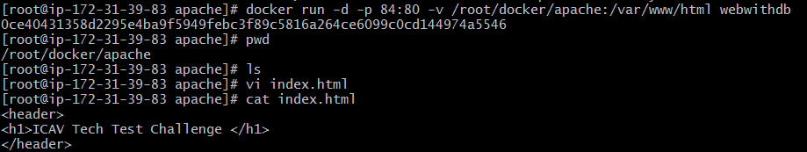

Refresh Browser

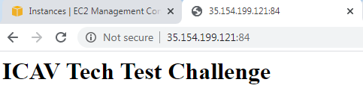

**Modify index.html in local machine**

<header>

<h1>ICAV Tech Test Challenge on 30.04.2020 </h1>

</header>

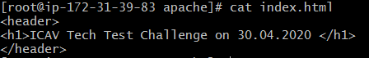

**Refresh the page automatically content will be updated**

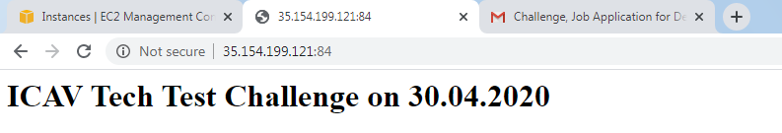

3. Create Github Actions Pipeline to Build the Docker image and push to Azure Container Registry

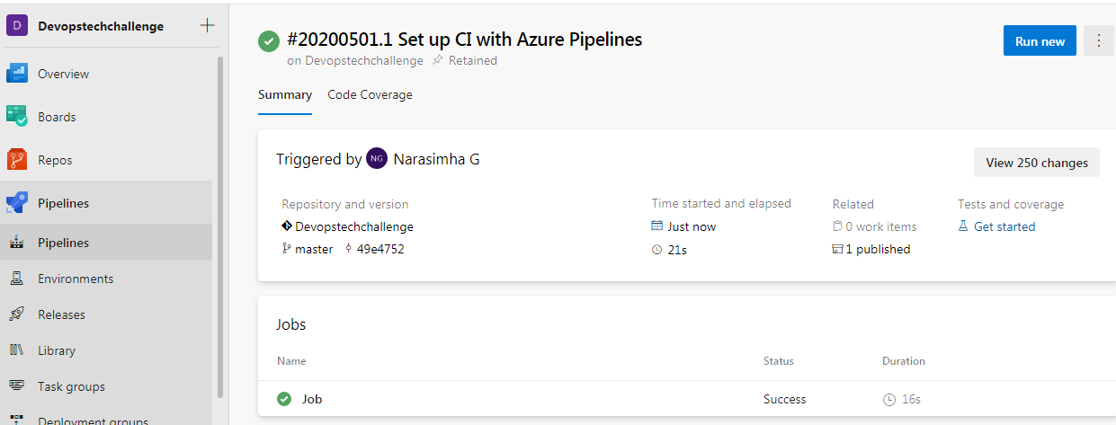

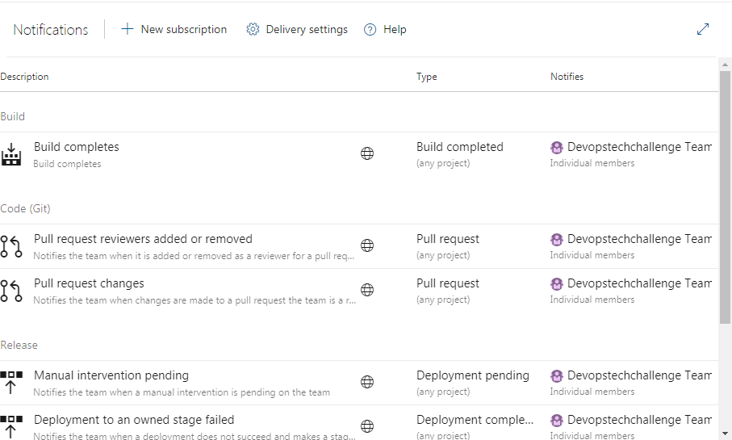

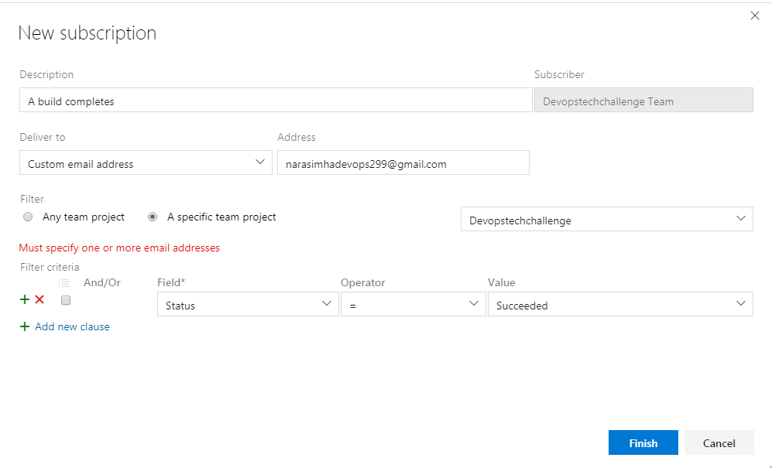

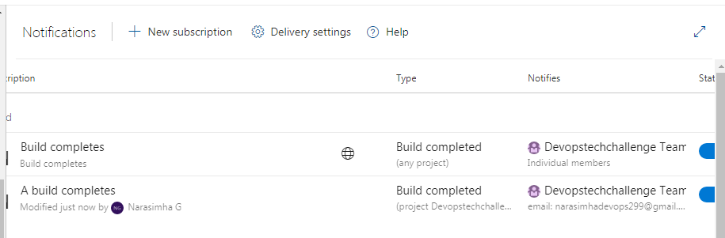

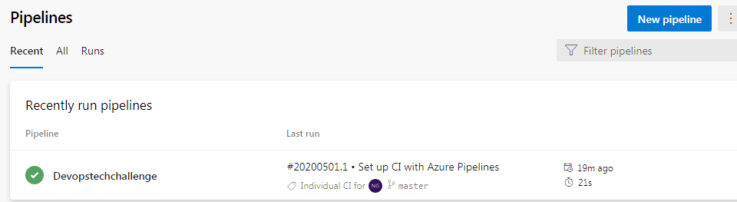

**Continuos Deployement**



